Problem 1: Number Theory Foundations for Public-Key Cryptography.
link: https://github.com/Jahnavikamarthi/AppliedCryptographyleet_code
is_prime(n): if n <= 1:
return False for i in range(2, int(n**0.5) + 1): if n % i == 0: return False return True def gcd(a, b): while b != 0:
a, b = b, a % b return a def phi(n): count = 0 for i in range(1, n + 1):
if gcd(i, n) == 1:
count += 1 return count # Input a = int(input("Enter first number: ")) b = int(input("Enter second number: "))
# Prime check
print("Is", a, "prime?", is_prime(a))
print("Is", b, "prime?", is_prime(b))
# GCD
g = gcd(a, b) print("GCD:", g) # Co-prime if g == 1:
print("Numbers are Co-Prime") else:
print("Numbers are NOT Co-Prime")
# Euler Phi phi_a = phi(a) phi_b = phi(b)
print("Phi(", a, ") =", phi_a) print("Phi(", b, ") =", phi_b)
# Fermat's Little Theorem (only if b is prime) if is_prime(b):
print("Fermat Test:", pow(a, b-1, b)) else:
print("Fermat Test not applicable (b is not prime)")
# Euler's Theorem (if co-prime) if g == 1:
print("Euler Test:", pow(a, phi_b, b))
else:
print("Euler Test not applicable (not co-prime)")
# Modular Arithmetic print("Mod Addition:", (a + b) % b) print("Mod Multiplication:", (a * b) % b)
print("Mod Exponentiation:", pow(a, b, b))

output:
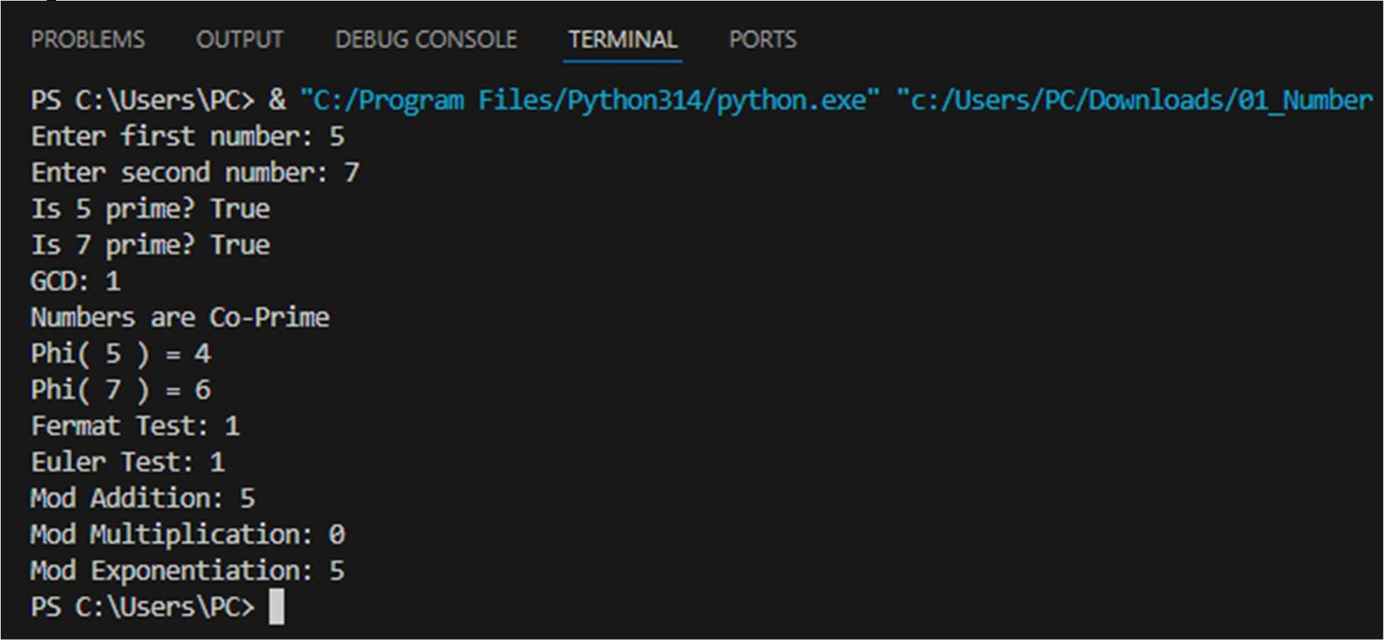

Problem 2: Algebraic Structures and Modular Arithmetic in Cryptography.
link: https://github.com/Jahnavikamarthi/AppliedCryptographyleet_code
n = int(input("Enter value of n for Z_n: ")) Z = list(range(n)) print("Set Z_n =", Z)
# Closure def is_closed_add(): for a in Z: for b in Z: if (a + b) % n not in Z:
return False return True def is_closed_mul(): for a in Z: for b in Z:
if (a * b) % n not in Z:
return False return True # Inverses def has_add_inverse(): for a in Z:
found = False for b in Z: if (a + b) % n == 0:
found = True if not found: return False return True def has_mul_inverse(): for a in Z[1:]: found = False for b in Z: if (a * b) % n == 1:
found = True if not found: return False return True # Results
add_closed = is_closed_add() mul_closed = is_closed_mul() add_inv = has_add_inverse() mul_inv = has_mul_inverse() print("Closed under Addition:", add_closed) print("Closed under Multiplication:", mul_closed) print("Additive Inverse exists:", add_inv) print("Multiplicative Inverse exists:", mul_inv)
# Decide structure if add_closed and add_inv and not mul_inv:
print("Structure: GROUP") elif add_closed and mul_closed and not mul_inv:
print("Structure: RING") elif add_closed and mul_closed and mul_inv:
print("Structure: FIELD") else:
print("Not a valid algebraic structure")

output:
